into this exclusive area, through the best of all experiences, your own. You’ll be able to enter, surrounded by pygmy palm trees, oaks and thymes, into the heart of the reserve itself which once, over a thousand years ago, was the exclusive domain of the Moorish ‘Bandoleros-Heroes.’ (Hero-thieves that surrounded the Andalucian area, travelling by horse. They held up the carriages passing through and sometimes shared some of their bounty with the poorer families in the area.)
For a day out and something completely different this is a fantastic area to visit and, whatever your interests, there is something for everybody from swimming to natural history, and you’ll be glad to have made the journey. If a day visit is not your style and more investigation is needed then you can always stay over. Throughout the area there are bed and breakfasts, guesthouses, two campsites, hotels and hostels catering for all requirements and tastes.
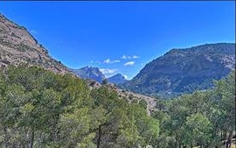
Restaurants
In this area you will find ‘El Mirador’ and ‘El Kioskoll’. These are traditional Spanish restaurants catering for around 200 people each and have wonderful views of the lakes and rolling countryside from their different viewpoints.
Wild life
Walking trails traverse the countryside around the gorge and offer stunning views of the wild terrain. The land is dry but rich in flora and fauna.
Amongst the vegetation are large ranges of Aleppo Pines, Spanish Junipers, Holm Oaks and olive trees, and also rosemary, thyme and rock-rose plants. Close to the sources of water many types of vegetation appear such as blackberries, climbing plants, willows, populus and eucalyptus plants. The fauna found here are of major value, with a multitude of protected species such as the Griffon Vulture, the Egyptian Vulture, the Golden Eagle, Bonelli’s Eagle, the Falcon, the Common Kestrel and the Spanish Ibex. Ardales Lakes and El Chorro Lakes
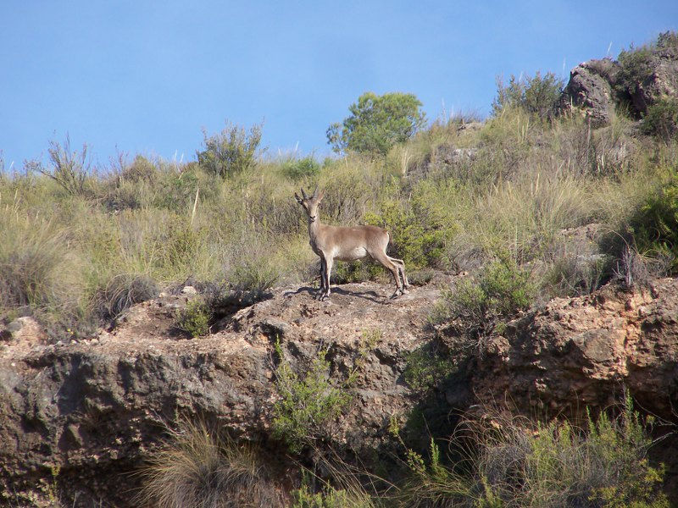
How to find the lakes.

Getting there is easy. Take the N340 to Malaga (coming from the Marbella direction) and, as you pass the newly built exhibition centre on your left, take the University turn off. As you take this junction you will do a full circle and join the A357 which heads off into the countryside. Stay on this road for approximately 40 minutes to an hour and then you have two alternatives. You can take the turn off for Alora and go through the village following the signs for El Chorro, or you can continue on the main road and follow the sign for Ardales/El Chorro. When you come to another sign for El Chorro you can go straight ahead to Lake Ardales or turn right to El Chorro itself.

The Ardales and El Chorro Lakes

Whether you are a resident or a visitor, Ardales Lakes, El Chorro are a must for anyone who enjoys something other than the hustle and bustle of the coast line. Less than one hour from Malaga or Marbella you are able to lose yourself in a truly Spanish environment and are guaranteed to be inspired by the beauty of the Lakes and all that surrounds them. This area is famous for the filming of’ spaghetti westerns’ and in El Chorro you will find the rail track where Frank Sinatra met his demise in the 1960s war film Von Ryan’s Express.
There are plenty of places to stay, from Bed & Breakfast to hotels, and there are also camping facilities for the more adventurous where you can hire paddle boats, canoes etc. This is also an area famous for hang gliding and is becoming one of the most popular centres for climbing in Europe.
Andalucia countryside villages.
Surrounding the Lakes there are many traditional villages and towns to visit including Pizarra, Alora, Ardales, Alhaurín el Grande, Alhaurín del Torre, Coin and Cartama.
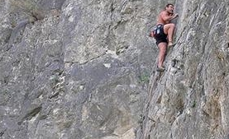
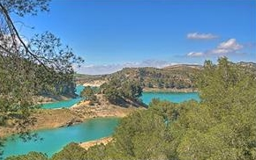
Ardales Lakes and the El Chorro area are a must-see and are only one hour’s drive from the coast line, situated in the heart of the Andalucian country side. This beautiful hideaway has three artificially built lakes created by a dam built across the Guadalhorce river gorge known as the ‘Garganta del Chorro’ and is an impressive 200 meters high.
The area boasts stunning views and is surrounded by vast pine forests and soaring limestone cliffs. The area has many activities on offer from rock climbing, hang gliding or mountain biking for the more active and adventurous to sunbathing, fishing, canoeing and scenic walks through breathtaking countryside if you’re more laid back. ‘Desfiladero de los Gaitanes’ with its vast richness and diversity justifies why in 1989 it was proclaimed a natural reserve by the Junta de Andalucia and, with naming it, it was hoped to preserve its incredible ecological value, extraordinary landscape and its historical and paleontological values.
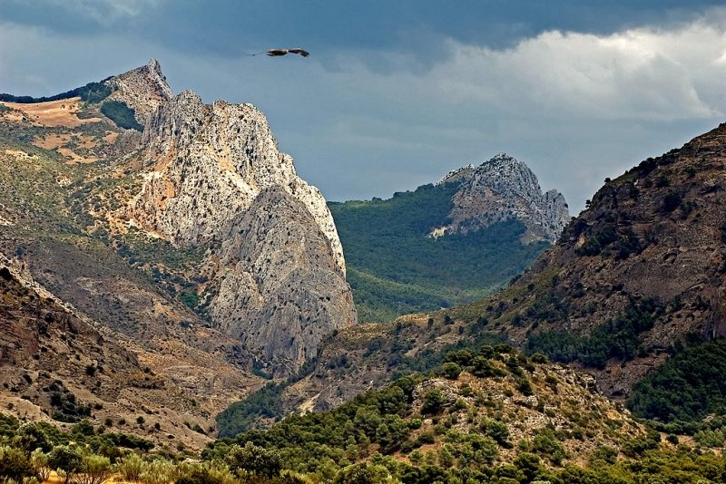
Malaga water reserve and electricity.
It is indeed the precipices, those deep cuts created by the Guadalhorce river on the natural limestone of the mountains, over 5 kilometers long and 400 metres deep that are the true attraction in the area. But when talking about the ‘Desfiladero de los Gaitanes,’ you cannot help but mention the manmade contributions, the river dams, which in this case were built to provide the city of Malaga with a continuous water source, to water the agricultural areas at the bottom of the Guadalhorce River and to generate electricity that, without a doubt, condition the character and look of the entire area.
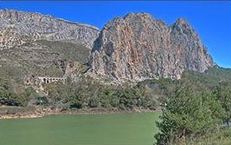
Although strictly speaking, the Natural Reserve only included the Gaitanejo River Dam, we would be unable to understand the dynamics and complexity of the open area without the river dams that surround it (Embalses del Conde de Guadalhorce, Guadalteba, Guadalhorce y Tajo de La Encantada), that make up, as a whole, one of the most important hydraulic complexes in Andalucia.
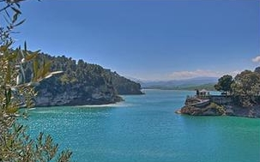
Camino del Rey (the King’s Path) Chorro Falls and Gaitanejo Falls.
All who choose to visit should see the Camino del Rey (the King’s Path) at El Chorro. This footpath was built to connect the ‘Salto del Chorro’ and the ‘Salto del Gaitanejo,’ both belonging to the Hydroelectric Society of El Chorro. It leads you through the Garganta de Los Gaitanes, a gorge which was used to cross between the huge rock faces that are over 400 meters high and some 200 meters above the Rio Guadalhorce.
In 1901 it was obvious that the workers of the Chorro Falls and Gaitanejo Falls needed a walkway to cross between the falls, to provide transport of materials, vigilance and maintenance of the channel. Construction of the walkway lasted four years and was finished in 1905. It was once walked by King Alfonso XIII of Spain in 1921,and was supposed to be under restoration, but as yet it has not been done.
The walkway has now gone many years without maintenance, and is in a highly deteriorated and dangerous state. It is one metre (3 feet) in width and is over 200 metres (700 feet) above the river. Nearly all the path has no handrail. Some parts of the walkway have completely collapsed and have been replaced by a beam and a metallic wire on the wall. Many people have lost their lives on the walkway in recent years. After four people died in two accidents in 1999 and 2000, the local government closed the entrances. However, adventurous tourists still find their way into the walkway.
Mirador de los Embalses (River Dam Viewpoint).
The Junta de Andalucia has made available a net of trails and a viewpoint, Mirador de los Embalses (River Dam Viewpoint) which allows you to get a true insight
